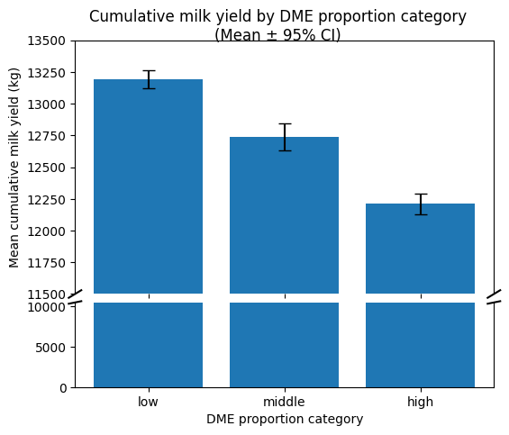
Figure 3. Mean cumulative milk yield over 305 days for 7,435 lactations, categorized by the proportion of milkings with DME within each lactation: low (≤20%), middle (>20% to ≤40%), and high (>40%). Error bars represent the 95% confidence intervals of the mean cumulative milk yield.

Tabel 2. Association of DME proportion during the lactation, parity, calving year and season with cumulative milk yield (m305).
Variable | DME as continuous variable¹ |  | DME as categorical variable¹
 | β ² | P -value³ | β ² | P -value³
Parity 2 | 2,045  (1,936, 2,155) | < 0.001 | 2,087  (1,976, 2,198) | < 0.001
Parity 3 | 2,265  (2,132, 2,398) | < 0.001 | 2,337  ( 2,202, 2,471) | < 0.001
Parity 4+ | 2,304  (2,172, 2,437) | < 0.001 | 2,409  (2,275, 2,542) | < 0.001
DME proportion | -154  ( -172, -136) | < 0.001
DME middle vs low |  |  | -206  (-326, -85) | 0.001
DME high vs low |  |  | -590  (-695, -485) | < 0.001
Calving year | 59  (-24, 143) | 0.16 | 93  (8, 177) | 0.03
Spring calving | 47  (-89, 183) | 0.45 | 37  (-100, 175) | 0.59
Summer calving | -44  (-174, 85) | 0.50 | -44  (-175, 87) | 0.51
Autumn calving | 24  (-107, 154) | 0.72 | 3  (-129, 135) | 0.97
¹Model categories include low (≤ 20%), middle (> 20 ≤40%), and high (>40%). The low DME proportion served as the reference category.
²The 95% confidence interval is given within brackets
³ Results with a P < 0.05 are highlighted in bold.

Tabel 3. Association of DME proportion during the lactation, parity, calving year and season with Peak yield (ypeak).
Variable | DME as continuous variable¹ |  | DME as categorical variable¹
 | β ² | P -value³ | β ² | P -value³
Parity 2 | 11.9  (11.4, 12.3) | < 0.001 | 12.0  (11.6, 12.5) | < 0.001
Parity 3 | 14.3  (13.8, 14.9) | < 0.001 | 14.5  (14.0, 15.1) | < 0.001
Parity 4+ | 14.1  (13.5, 14.6) | < 0.001 | 14.4  (13.9, 15.0) | < 0.001
DME proportion | -0.5  (-0.5 , -0.4) | < 0.001
DME middle vs low |  |  | -0.3  (-0.7, 0.2) | 0.31
DME high vs low |  |  | -1.8  (-2.3, -1.4) | < 0.001
Calving year | -0.6  (-0.9, -0.2) | 0.001 | -0.5  (-0.8, -0.1) | 0.01
Spring calving | 0.6  (0.1, 1.2) | 0.03 | 0.6  (0.0, 1.1) | 0.04
Summer calving | -0.3  (-0.8, 0.2) | 0.26 | -0.3  (-0.8, 0.2) | 0.27
Autumn calving | -0.4  (-0.9, 0.1) | 0.14 | -0.44  (-1.0, 0.1) | 0.10
¹Model categories include low (≤ 20%), middle (> 20 ≤40%), and high (>40%). The low DME proportion served as the reference category.
²The 95% confidence interval is given within brackets
³ Results with a P < 0.05 are highlighted in bold.

Tabel 4. Association of DME proportion during the lactation, parity, calving year and season with time to peak (tpeak).
Variable | DME as continuous variable¹ |  | DME as categorical variable¹
 | β ² | P -value³ | β ² | P -value³
Parity 2 | -33.3  (-34.9, -31.7) | < 0.001 | -33.2  (-34.8, -31.6) | < 0.001
Parity 3 | -35.9  (-37.8, -33.9) | < 0.001 | -35.6  (-37.6, -33.7) | < 0.001
Parity 4+ | -36.0  (-37.9, -34.0) | < 0.001 | -35.7  (-37.6, -33.7) | < 0.001
DME proportion | -0.5  (-0.8, -0.3) | < 0.001
DME middle vs low |  |  | -0.8  (-2.5, 0.9) | 0.38
DME high vs low |  |  | -2.2  (-3.7, -0.7) | 0.01
Calving year | 6.6  (5.3, 7.8) | < 0.001 | -0.5  (5.4, 7.9) | < 0.001
Spring calving | -4.2  (-6.2, -2.3) | < 0.001 | -4.3  (-6.3, -2.3) | < 0.001
Summer calving | -1.0  (-2.9, 0.9) | 0.31 | -1.0  (-2.9, 0.9) | 0.31
Autumn calving | 1.7  (-0.3, 3.6) | 0.09 | 1.6  (-0.3, 3.5) | 0.10
¹Model categories include low (≤ 20%), middle (> 20 ≤40%), and high (>40%). The low DME proportion served as the reference category.
²The 95% confidence interval is given within brackets
³ Results with a P < 0.05 are highlighted in bold.

Tabel 5. Association of DME proportion during the lactation, parity, calving year and season with log-transformed persistency.
Variable | DME as continuous variable¹ |  |  |  | DME as categorical variable¹
 | β ² | P -value³ | % change⁴ | β ² |  | P -value³ | % change
Parity 2 | -0.97  (-1.02, -0.93) | < 0.001 | -62% | -0.98  (-1.02, -0.93) |  | < 0.001 | -62%
Parity 3 | -1.10  (-1.16, -1.05) | < 0.001 | -67% | -1.11  (-1.16 , -1.05) |  | < 0.001 | -67%
Parity 4+ | -1.14  (-1.19, -1.09) | < 0.001 | -68% | -1.15  (-1.20 , -1.09) |  | < 0.001 | -68%
DME proportion | 0.00  (-0.00, 0.01) | 0.40 | 0%
DME middle vs low |  |  |  | -0.05  (-0.10 , -0.00) |  | 0.04 | -5%
DME high vs low |  |  |  | 0.00  (-0.02, 0.04) |  | 1.00 | 0%
Calving year | 0.10  (0.10, 0.14) | < 0.001 | 11% | 0.10  (0.07, 0.13) |  | < 0.01 | 10%
Spring calving | -0.01  (-0.06, 0.05) | 0.77 | -1% | -0.01  (-0.06, 0.05) |  | 0.79 | -1%
Summer calving | 0.02  (-0.03, 0.07) | 0.49 | 2% | 0.02  (-0.03, 0.07) |  | 0.51 | 2%
Autumn calving | 0.09  (0.04, 0.14) | 0.001 | 9% | 0.09  (0.04, 0.14) |  | 0.001 | 9%
¹Model categories include low (≤ 20%), middle (> 20 ≤40%), and high (>40%). The low DME proportion served as the reference category.
²The 95% confidence interval is given within brackets
³ Results with a P < 0.05 are highlighted in bold.
⁴ Because persistency was log transformed, coefficients were exponentiated to obtain the percentage change in persistency associated with a one-unit increase or decrease in the predictor variable, or relative to the reference category.

 | Cumulative milk yield | Peak yield
Random forest | 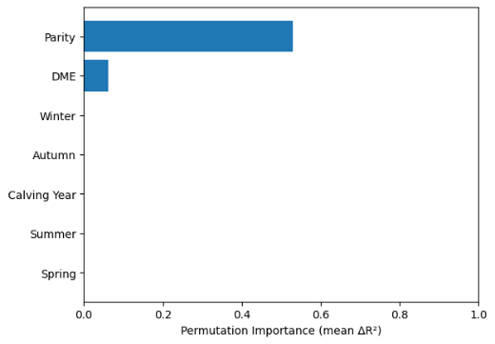 | 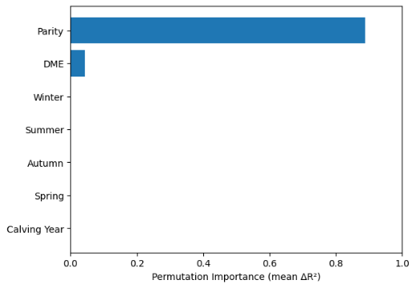
XGBoost | 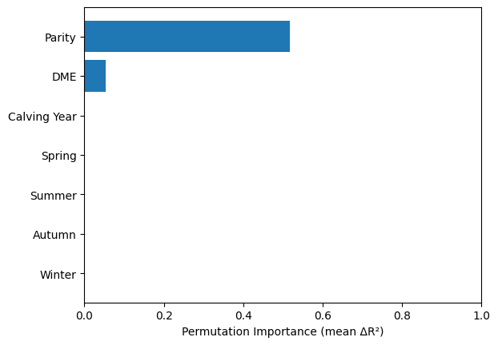 | 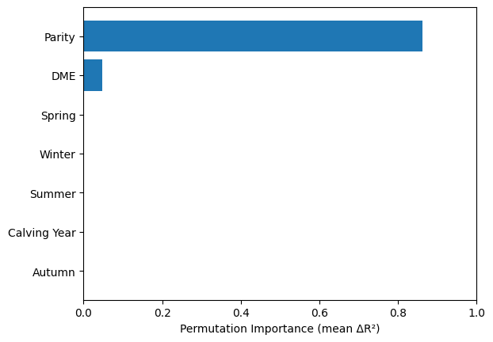
 | Time to peak | Persistency
Random forest | 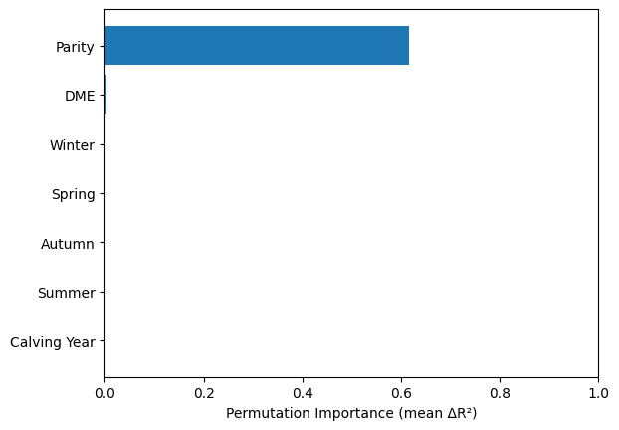 | 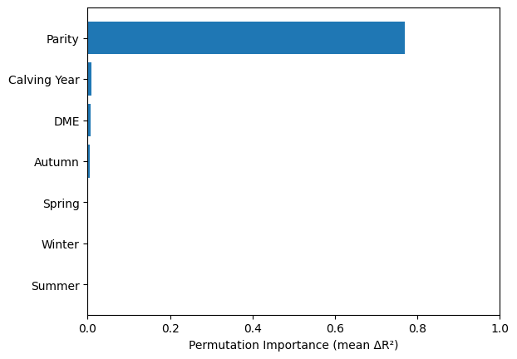
XGBoost | 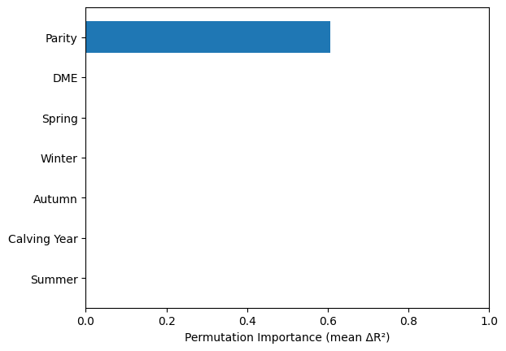 | 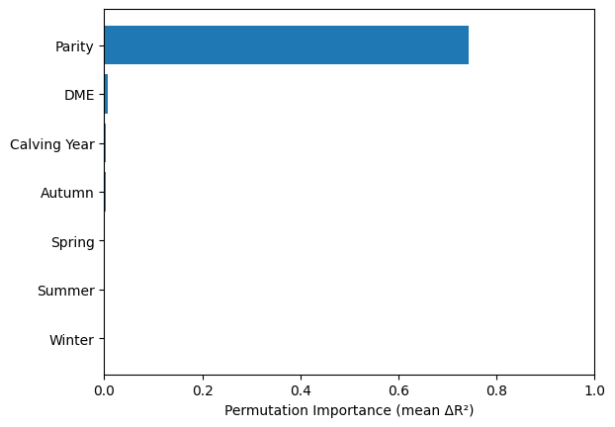
Figure 5. Permutation feature importance of the tree models: random forest (first and third row) and XGBoost (second and fourth row) for each lactation curve characteristic. Visualizes the decline in model performance, R² after random permutation of the predictor in the test set averaged over 30 permutations (∆R²) . A bigger decline in R² signifies higher feature importance, while no reduction can be seen if the variable is not predictive for the outcome.

 | Cumulative milk yield | Peak yield
Random forest | 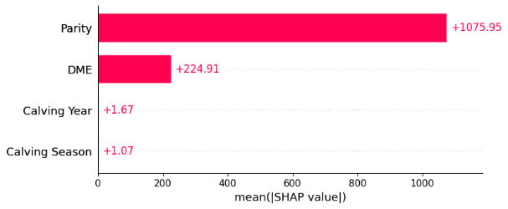 | 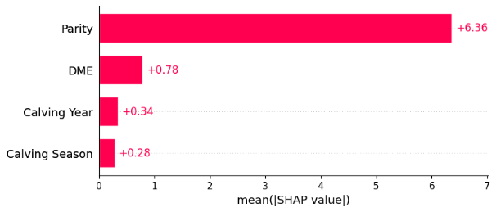
XGBoost | 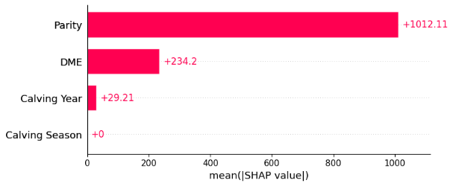 | 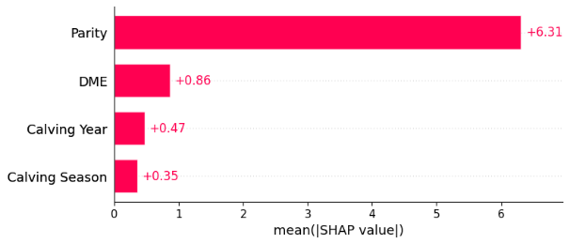
 | Time to peak | Persistency
Random forest | 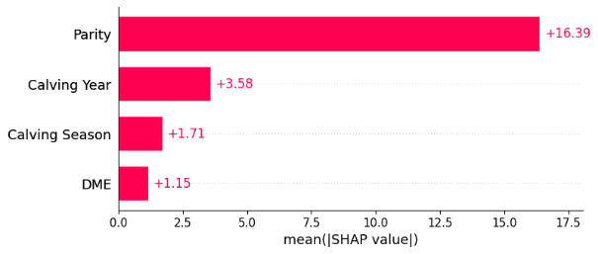 | 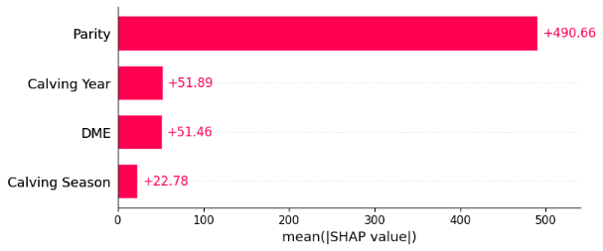
XGBoost | 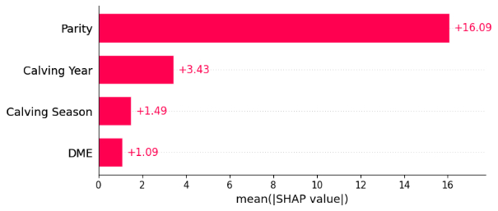 | 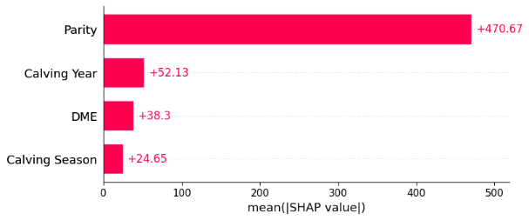
Figure 6. Feature importance based on average absolute Shapley values for each tree-based model. The Shapley value quantifies how much a predictor contributed to the final prediction and can therefore be used as a metric for feature importance. For all models parity was the most important feature. The importance of DME differed per LC characteristic, with the highest importance for cumulative milk yield.

 | Cumulative milk yield | Peak yield
Random forest | 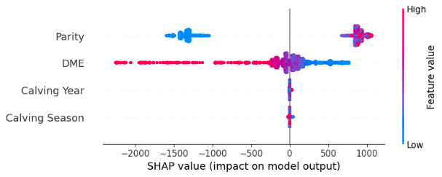 | 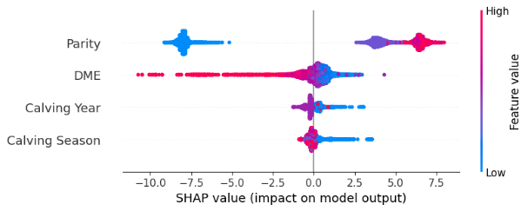
XGBoost | 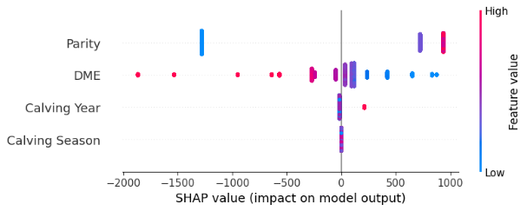 | 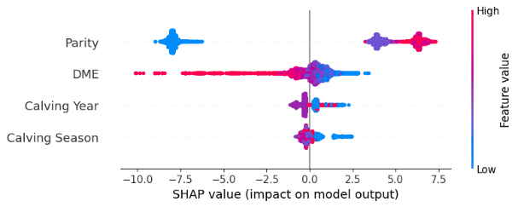
 | Time to peak | Persistency
Random forest | 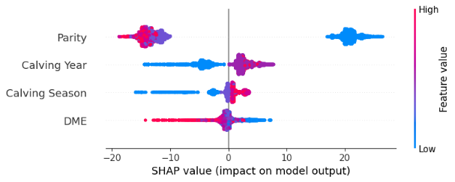 | 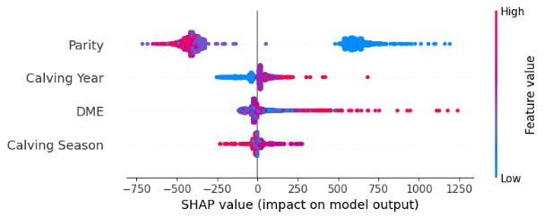
XGBoost | 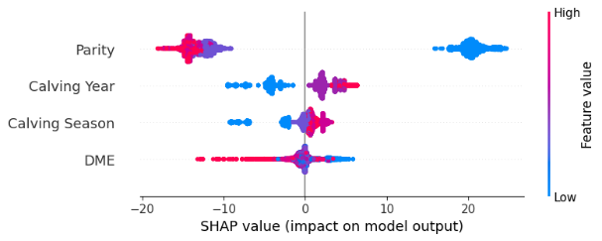 | 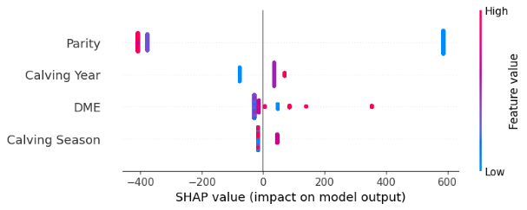
Figure 7. Beeswarm plots for the tree-based models. A SHAP beeswarm plot depicts the distribution and magnitude of feature contributions across all model predictions, showing both the importance of each feature (x-axis) and how different feature values influence the prediction direction (color). The SHAP values of observations with a DME proportion on the outside of the distribution have a much bigger influence on the final predictions while average feature DME proportion has a SHAP value of almost zero in all the models.

